2-Transport mechanisms (requiring energy from cells)
The cell needs to transport molecules against their concentration gradient (from low to high concentration) and that needs energy which provide by ATP hydrolysis.
There are many types of mechanisms that require energy to transport different material across P.M.:
A- Active transport is the movement of substances like ions against its concentration gradient (from low to high concentration).
Both carrier proteins and energy are needed to transport molecules against their concentration gradient. In this case, chemical energy (ATP) is required for the carrier proteins to combine with the substance to be transported.
For example the kidney cells have a large number of mitochondria (to create energy) near membranes where active transport is occurring.
Active transport is usually associated with accumulating high concentrations of molecules that the cell needs, like ions, glucose and amino acids. Examples of active transport include the uptake of glucose in the intestines in humans.

B- Bulk transport is the movement of substances or macromolecules across membrane within a small vacuole that's means that the large molecules and particles move through membrane enclosed by vesicles formed by parts of cell membrane.
These processes are grouped according to whether materials are moved into or out of the cells in which both needs energy as follows:
1-Endocytosis
Cells uptake molecules and particles from surrounding media through plasma membrane to inside the cytoplasm in which material a cross through plasma membrane invigilates to inside the cell to form vesicle containing ingested material. Endocytosis occurs in one of three ways
a-Phagocytosis (cell eating)
Occurs when the materials enter the cell in which cells engulf large particles like bacteria and debris. The particles bound to the receptors on the surface of phagocytic cells, cytoplasmic process (pseudopodia) of the cell are extended and surround the particles and form vesicle called phagosome. Phagosomes then fuse with lysosome to form phagolysosome. Lysosomal enzymes digest the content and the indigested particles are retained within vacuoles which termed residual bodies
Certain white blood cells like neutrophil and macrophage are specialized for engulfing and removing particles like bacteria and dead cells.
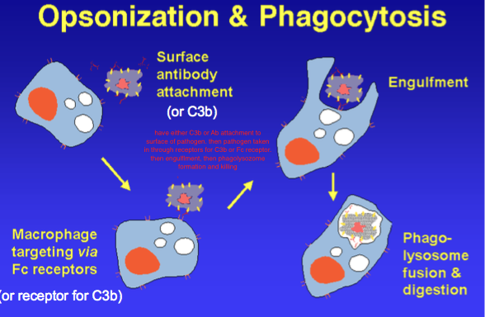

b-Pinocytosis (cell drinking)
Occurs when the plasma membrane folds inward to form a channel allowing dissolved substances to enter the cell.
When the channel is closed, the liquid is encircled within a pinocytic vesicle, these pinocytotic vesicles subsequently fuse with lysosomes to hydrolyze (break down) the particles and may move to the cell surface opposite their origin , they fuse with the plasma membrane and release their contents outside the cell. This process is termed transcytosis and requires energy in the form of adenosine triphosphate (ATP), the chemical compound mostly used as energy in the majority of animal cells.

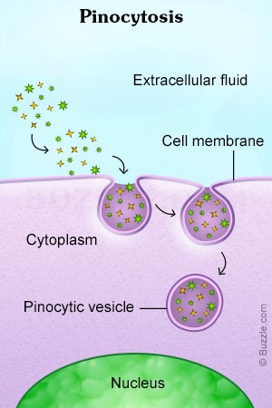

c-Receptor mediated endocytosis
Receptor mediated endocytosis is the process by which the material called ligands (molecules with high affinity for a receptor) like absorb metabolites, hormones, other proteins – and in some cases viruses binds directly onto the receptor protein of the cell-membrane.
When many receptors are bound by their ligands they aggregate in some membrane region which then invaginates and forming vesicles (contain both receptors and its bound ligands). These vesicles quickly enter and fused with one or more vesicle of the endosomal compartment (a dynamic system of vesicles and tubules)
The acidic PH (because endosome contains ATP-H⁺ driven pumps) of endosome makes many ligand separate from their receptors and sorted into other vesicle .The vesicles that empty from receptors return to the cell surface and the receptors may be reunited to the cell membrane to be reused again while the ligands are typically transferred to late endosome which fused with lysosomes for digestion of their contents..

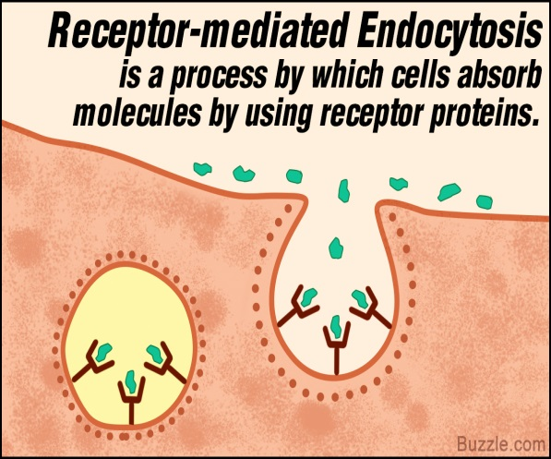

2-Exocytosis

Exocytosis is the opposite of endocytosis (in which substances are taken into cells), like waste products or molecules for export like hormones and proteins.
In exocytosis, membrane-bound vesicles containing large amount of cellular molecules are transported to the cell membrane. The vesicles fuse with the cell membrane and expel their contents to the exterior of the cell.

Both endocytosis and exocytosis are used by all cells because the important molecules for the cells are large molecules and cannot pass through passive transport so they needs energy to transport this molecules across plasma membrane and making a form of bulk transport.

